PSSI Science Project Reporting Template

️ | The PSSI Implementation Team is compiling a technical report to demonstrate the important research and advancements made by the Science Branch through the PSSI funding. The technical report will include a 3-4 page summary (including graphics and figures) for each project to show their key results and findings. Please fill in the following fields and sections for your project to be included in the report. Feel free to include and draw from any reports or presentations previously created through your research.  A plain language science bulletin will also be created to follow up on last year’s “DFO Pacific Region Science Bulletin, 2024. New research and monitoring for Pacific salmon and their ecosystems.” While the first bulletin introduced project backgrounds, methods, and timelines, this new bulletin will highlight the projects’ results, key findings, and conclusions with links to reports and data available. The bulletin will include a 1-2 page summary for each project gleaned from the content entered below.  ️ Completed forms are due January 7, 2026.  *Please include or send separately any graphics or pictures (with photo credits) that will help promote the projects.

PART 1: PROJECT METADATA

General Project Information
Project ID (number) | Project Title
2443 | Quantitative assessment of the impact of Smallmouth Bass suppression efforts in Cultus Lake and SMB emigration from Cultus Lake
Project Leads | Collaborations and External Partners
Dan Doutaz | Province of British Columbia  Simon Fraser University
Location (if applicable) | Province of British Columbia  Simon Fraser University
Cultus Lake; Fraser River | Province of British Columbia  Simon Fraser University

Geographic and Stock Information
Salmon species (if applicable) | Waterbodies (if applicable)
Sockeye Salmon | Cultus Lake
Life history phases (if applicable) | Region
Juvenile (fry & smolt) | Pacific (Fraser River)
Stock (if applicable) | Population (if applicable)
Cultus Lake | Click or tap here to enter text.
Conservation Unit (if applicable)
Cultus-L

🧰 PART 2: PROJECT METRICS

Project Outputs
Include any anticipated outputs denoted as (in progress). Please include links to any outputs available online so they can be referenced in the report.
List scientific publications and technical reports (with links)
Final report pending (to be written by partners at Simon Fraser University with input from DFO and the Province of British Columbia)
List datasets generated (with links)
A series of Excel spreadsheets were generated between 2023 – 2025, which are now summarized in a shinyapps database managed by the Province of BC.
Describe dataset locations and data management systems
Excel databases are stored at DFO in Kamloops; the shinyapps database is a summary of these databases and stored with the BC Ministry of Water, Land and Resource Stewardship.
List code, programs, or other software created (with links)
N/A
List communication or social media products
N/A
List and describe field work completed
Electrofishing for smallmouth bass 2023-2025 (included a combination of PIT tagging, acoustic tagging, biological sampling, euthanization).

List and describe samples collected/analyzed (number of samples)
3,654 biological samples (length, weight, maturation, sex; subset of stomach contents, scales, otoliths) were taken from SMB between 2023-2025. Of these samples, 268 stomach samples, 2,069 scale samples, and 20 otoliths samples were collected.
List and describe large capital assets or equipment acquired
N/A

PART 3: WRITTEN CONTENT

Highlights
Please summarize in 2-3 bullets:
- The main idea of the project
- Key findings
- Implications of these findings for salmon and decision-makers
- For a more technical audience, but still as plain language as possible
- Smallmouth Bass (SMB) were recently introduced into Cultus Lake and pose a significant risk to native species in the system, including endangered Cultus Late Run Sockeye salmon and Pygmy Sculpin. The main goal of this project was to investigate the population dynamics of SMB in Cultus Lake, explore suppression methods that can be employed in future years to manage SMB to reduce impacts on native species in the lake, and minimize expansion of the population downstream into other areas of the lower Fraser River.
- Key findings of this project indicate that the SMB population in Cultus Lake is expanding despite suppression efforts, and downstream movement through Sweltzer Creek towards the Vedder River has been detected at the DFO-operated juvenile enumeration fence. Biological samples have confirmed predation of SMB on juvenile salmonids and sculpin, confirming the potential risk on endangered Sockeye Salmon and Pygmy Sculpin, among other native species in the lake. Electrofishing has been shown to be extremely effective for suppression during the spring when SMB occupy near-shore habitat to build nests and spawn, however depths in which SMB occupy for most of the year (>20 feet) precludes their capture by electrofishing. In addition to SMB, the presence of Pumpkinseed, another non-native invasive species, was detected in Cultus Lake as part of this work. Since 2023, catch rates of Pumpkinseed while electrofishing have increased by ~1,200% indicating the population is rapidly expanding and poses a significant secondary risk to native species in the lake.
- This project has highlighted the risk SMB (and also Pumpkinseed) pose both for native species within Cultus Lake, and in other areas of the Lower Fraser River if these populations continue to expand. Suppression efforts need to continue through time to both limit trophic effects within the lake, and downstream movement into the Fraser River through Sweltzer Creek.

Background
Please provide 1-2 paragraphs to summarize
- The relevant biological, environmental, and/or management context
- What knowledge gap or demand were you trying to fill?
- Collaboration and partner relationships
Smallmouth bass (Micropterus dolomieu), a piscivorous fish species native to eastern North America, have been introduced into Cultus Lake, British Columbia. Cultus Lake is home to endangered sockeye salmon (Oncorhynchus nerka) as well as endemic Cultus pygmy sculpin (Cottus aleuticus). Smallmouth bass introduced in other salmon-bearing habitat have been observed to exert substantial mortality on salmon fry and smolts, suggesting a similar impact may be possible in Cultus Lake. Observations of sockeye salmon, and Cultus pygmy sculpin in the diet of captured smallmouth bass, demonstrates predation upon two native species at risk. While smallmouth bass represent a threat to the Cultus Lake native fish community and species at risk specifically, they are also highly valued by some anglers. Importantly, as a source population, they also represent a real and present threat to other ecosystems in the Lower Mainland. Smallmouth bass are often found in streams and rivers; in fact, they have already been found downstream of Cultus Lake. Additionally, there is the threat of anglers moving smallmouth bass to other waterbodies in the Lower Mainland to create new bass fisheries, which themselves would create risk to receiving environments. While there are largemouth bass (M. salmoides) populations in various waterbodies throughout the Lower Mainland, this is the first verified smallmouth bass population, and has drawn a lot of attention from the angling community. Early work on this population has identified a divergence of public opinions: some value native species (especially sockeye salmon) and want to see bass suppressed; other values angling opportunities for smallmouth bass and will strongly oppose any measures to affect this valued fishery resource.

There are two issues that this project addresses: (1) understanding which suppression options will result in the lowest opposition from anglers and community members, thereby identifying the risk of unintended consequences (e.g., additional transfers to other lakes); and (2) determining the suppression strategy (combination of different suppression options) which will best inform estimates of effectiveness for each suppression option so as to maximize effective suppression moving forward to reduce impacts on sockeye salmon recruitment.

This project was conducted in collaboration with the Province of British Columbia (Ministry of Water, Land and Resource Stewardship), and Simon Fraser University.

️ Methods and Findings
Please insert a few paragraphs to summarize:
- Main methods used
- Products and tools produced
- Advancements in methodology, technology, and application
- Advancements in communication and knowledge transfer
- Key results and information generated
Electrofishing and angling was conducted in the spring to target SMB as they move to near-shore habitat to build nests and spawn. The perimeter of Cultus Lake was divided into quadrants (Figure 1) and swept with a boat electrofishing unit to target spawning SMB. In 2023, ten consecutive days of electrofishing were conducted (June 1-10, 2023), and all SMB captured (by electrofishing and angling) were implanted with a PIT tag and released to get an initial baseline of the population in 2024. A subset of SMB (n=25) were also implanted with acoustic transmitters to track movements within the lake, and downstream movement from the lake (acoustic receivers also deployed in 2023 in various locations). In 2024, two consecutive days (east side of lake day one; west side of lake day two) of electrofishing and angling were conducted for six consecutive weeks (May 9 – June 7, 2024), and all SMB were euthanized to get a PIT tag recovery sample and to see how the population responded to the cull the following year. In 2025, operations were conducted in two day intervals, for seven consecutive weeks (May 1 – June 13, 2025). For the first two weeks of the project all SMB were euthanized to reduce the spawning potential of the population, and for subsequent weeks 25% of all SMB were implanted with PIT tags and released. A subset of 44 SMB were also implanted with acoustic transmitters to track movements within, and from Cultus Lake. A total of 3,654 biological samples (length, weight (Figure 2); subset of stomach contents (Figure 3), scales, otoliths) were collected from SMB between 2023-2025. Of these samples, 268 stomach samples, 2,069 scale samples, and 20 otoliths samples were collected. Age analysis and acoustic tracking results are pending, and will be included in the final report (written by SFU).

Between 2023 and 2025, a total of 6,650 SMB were captured by a combination of electrofishing and angling (942 in 2023, 1,616 in 2024, 4,092 in 2025; 95% by electrofishing, 5% by angling). A total of 1,469 PIT tags were deployed (897 in 2023, 572 in 2025), and 69 acoustic tags were surgically implanted in SMB (25 in 2023, 44 in 2025). Of the PIT tags deployed in 2023, 47 were recaptured in 2024 (4.8% recovery) and 12 were recaptured in 2025 (1.2% recovery), giving a rough population estimate of approximately 16,000 SMB in 2024. However, observations from staff at the Cultus Lake Laboratory, the Province of BC, and anglers have indicated a significant portion of the population occupy habitat at depths that preclude SMB from capture by electrofishing, thus, this estimate is likely biased low. The PIT tags deployed in 2025 have yet to be captured in 2026, therefore a current population estimate is unavailable at this time. It should be noted that in 2023, a total of two Pumpkinseed were captured during the electrofishing program. In 2024 the number increased to 60, and in 2025 increased to 2,553. Further to this, the capture of Pumpkinseed was incidental as there is some overlap in habitat with SMB, and if efforts were targeted for Pumpkinseed (i.e. heavily vegetated near-shore habitat), those numbers would be higher. The rapid increase in Pumpkinseed bycatch over the course of this work is alarming and should be investigated in future years.

The subset of stomach samples taken, approximately 10% of samples contained juvenile salmonids (fry or smolt stage), and 2% contained sculpins. It is noted that many stomach samples were at an advanced stage of digestion therefore these estimates are biased low. Acoustic tracking of SMB is ongoing and will be discussed in the final report. However, between 2024 and 2025 a total of 17 SMB were captured at the DFO-operated smolt enumeration fence (run March – June annually), indicating some downstream movement of SMB in Sweltzer Creek to the Vedder River (tributary to the Fraser River). At this time there are no confirmed reports of SMB in the Vedder or Fraser rivers, however, as the population in Cultus Lake expands, downstream colonization is likely.

The following results, in addition to acoustic tracking data, an evaluation of suppression methods (paired with feedback from the public and social survey results), and up-to-date SMB population estimates will be presented in the final report written by SFU, DFO and the Province of BC in 2027.

Insights
Please insert a few paragraphs to summarize:
- What this project has added to knowledge about salmon populations, health, or ecosystems.
- How this project informs salmon management:
  - decisions
  - policy guidance
  - trade-offs
  - planning
- Addition of knowledge to understanding:
  - limiting factors/stressors/threats/ pathways of effects/risks
  - biologically significant thresholds
  - cumulative impacts
- Sources of uncertainty
This work has highlighted the Cultus Lake ecosystem is in peril with the introduction and expansion of not only SMB, but also Pumpkinseed, threatening two endangered species (Sockeye salmon and Pygmy sculpin) and a variety of other native pacific salmonid populations (Chinook, Coho. Chum, Pink, trout sp.). Cultus Lake is a unique ecosystem that is also one of the most popular recreational lakes in the lower Fraser watershed and concurrently faces other threats (e.g. eutrophication/water quality issues, invasive plant encroachment) that likely cumulatively impact native species within the lake, particularly those of conservation concern with severely depressed abundance. Further to this, the presence of SMB and Pumpkinseed in Cultus Lake threatens the entire lower Fraser watershed as downstream movement from this source population has already been detected at the DFO juvenile enumeration fence for two consecutive years (2024 and 2025).

Given the conservation concerns for Sockeye salmon and Pygmy sculpin (both Red status under SARA), management decisions and mitigation planning should place a great emphasis on long-term suppression of SMB and Pumpkinseed to reduce the immediate predation impacts on native species, in addition to other cumulative threats such as habitat degradation from invasive plants and water quality issues that will inevitably lead to trophic effects within Cultus Lake.

⏩ Next Steps
Please insert 1-2 paragraphs to summarize:
- Remaining knowledge gaps and recommendations for future studies
- How can/should the project findings be operationalized for salmon conservation and management?
Sources of uncertainty and recommendations raised from this work include:
- The total population size of SMB in Cultus Lake is currently unknown, given a portion of the population occupies habitat that precludes capture by electrofishing. Future work should explore alternative methods of capture (e.g. increased angler effort, spearfishing, trapping) to target this portion of the population.
- The degree of SMB predation on endangered Sockeye Salmon and Pygmy Sculpin is unclear as many samples were at an advanced stage of digestion and were not analyzed for DNA. Future work should include a more thorough analysis of SMB gut contents to inform conservation measures for these species.
- The rapid increase in Pumpkinseed bycatch (1 in 2023, to 2,553 in 2025) over the course of this work is alarming, and further work is needed to determine critical habitat within Cultus Lake, the source population (natural reproduction vs. continued introductions), and a suppression plan created to limit further expansion.

This work has shown electrofishing to be an effective tool for SMB management, in addition to other invasive species that occupy near-shore habitat year-round or during their spawning period (e.g. bass, northern pike, pumpkinseed, crappie, perch, etc.). Electrofishing could be expanded into other areas of the lower Fraser River (e.g. sloughs, side channels, etc. to target other persistent populations of invasive species such as largemouth bass, sunfish sp., bullhead sp., perch, among others) and other areas of the watershed that house invasive species (e.g. Nicola Lake yellow perch, Pitt Lake largemouth bass).

📈 Tables and Figures
Please provide captions and numbering for any tables and figures. Graphics can be copied below or e-mailed separately.
- Include a brief caption with each figure and table in the box below
- Number each table and figure, and include references in the above sections where appropriate.
- 1-3 figures are recommended per project
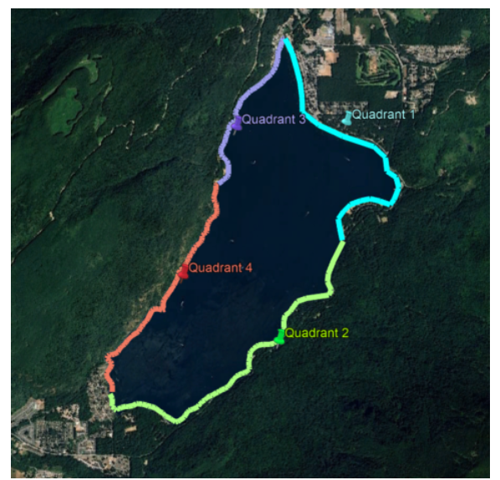
Figure 1. Map of Cultus Lake electrofishing quadrants.

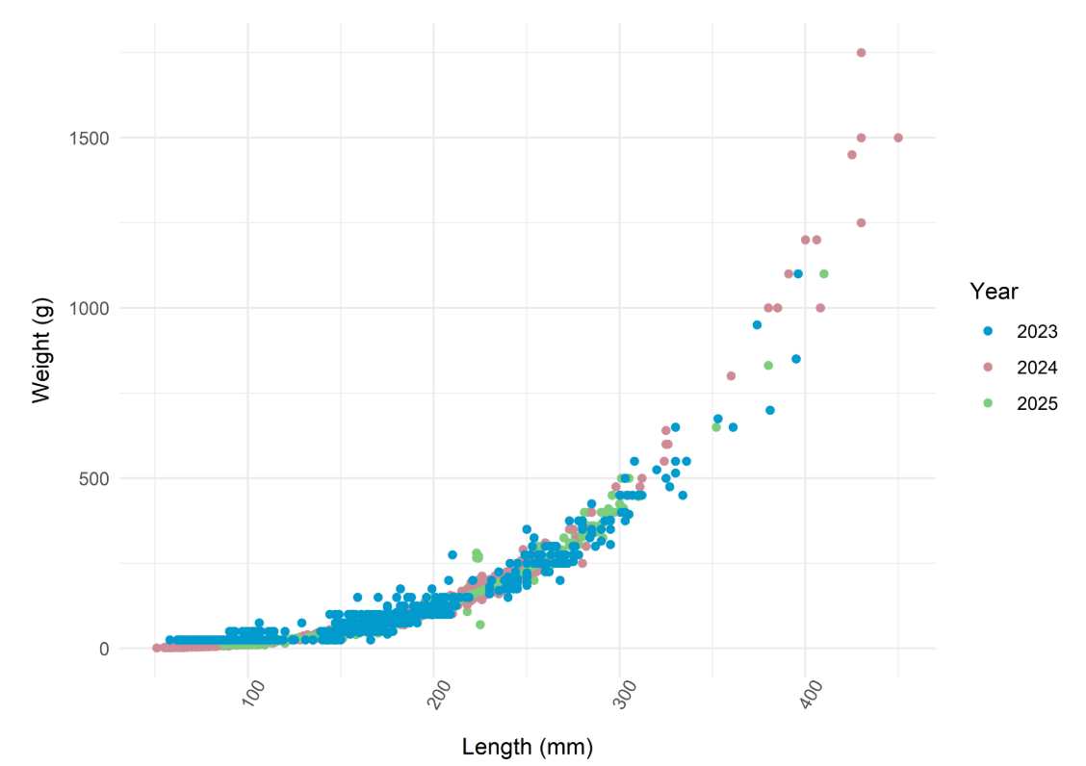
Figure 2. Lengths and Weights of all bass sampled between 2023-2025 (n=3,654).

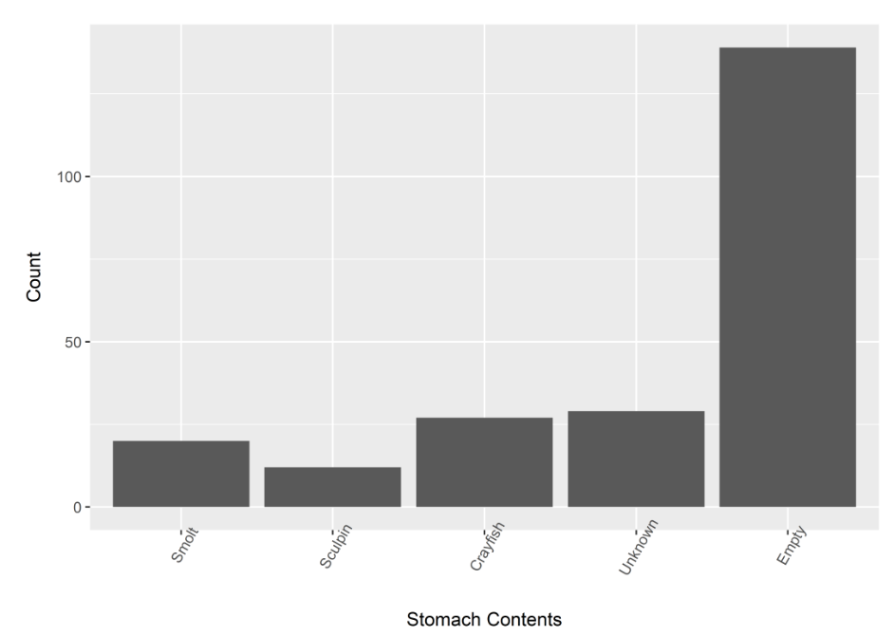
Figure 3. SMB gut contents from a subsample of biological samples taken between 2023-2025.

📈 References
Include full references for any publications referenced in other sections. Please format references in Harvard style according to Instructions to Authors for the Canadian Journal of Fisheries and Aquatic Sciences, at Canadian Science Publishing.
Click or tap here to enter text.

